**Ramolatela Lebaea**

**221064591**

**Dimming effect on four additional LEDs based on the Pulse Width Modulation PWM control**

In this lab, the main goals are to connect a potentiometer to measure voltage and display it on 8 LEDs, show the binary bits of the voltage on one set of LEDs, use the same voltage to control the brightness of one LED using Pulse Width Modulation (PWM), and implement a special dimming effect on four additional LEDs based on the PWM control. This lab helps us learn about voltage measurement, binary representation, and controlling light intensity. PWM stands for Pulse Width Modulation, a way to control things like the brightness of LEDs or the speed of motors by rapidly turning the power on and off. The longer it's on, the brighter or faster it appears, similar to flickering a light switch quickly to control the amount of light, making things seem dim or bright.

Analog-to-digital conversion (ADC) is a process in electronics where a continuously changing analog signal is converted into a digital signal made up of distinct levels without altering its core information. An ADC takes an analog signal, which smoothly changes over time and amplitude, and transforms it into a digital signal that has specific, well-defined values in terms of both time and amplitude. The input analog signal typically involves voltage and can take on a practically infinite number of values, including signals like sine waves, human speech waveforms, and the signals used in regular television cameras.

# APPARATUS

* 17× LED of which 8 are compulsory (3 green, 2 yellow and 3 red)
* 17× 220Ω Resistors
* 1× Potentiometer
* Breadboard
* Connecting wires
* Arduino

# OUTPUT AND ANALYSIS OF RESULTS

*Figure 1: Lower level*

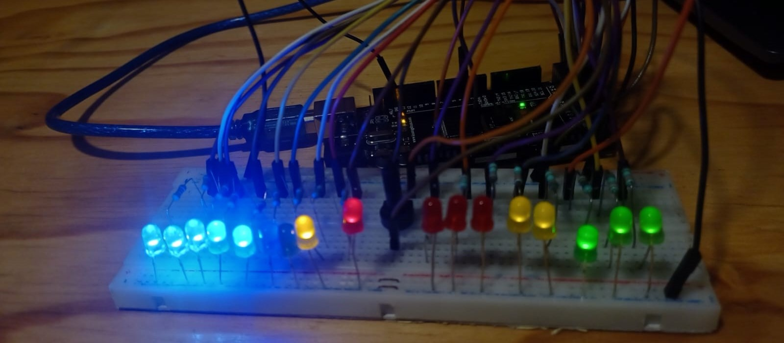

*Figure 2: Middle level*

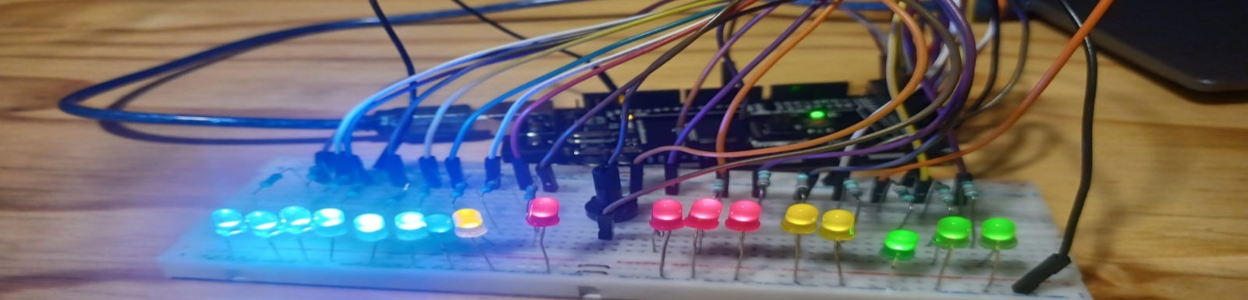

*Figure 3: Higher level*

As shown in Figures: 1, 2 & 3 above. The LEDs in the LHS represent the bit stream and the LEDs in the RHS represent the bit stream. So when the potentiometer is at zero, all LEDs are off, but when the potentiometer is at its low levels, green LEDs are high, middle level: yellow and green LEDs are high, upper level: all the LEDs are high including the PWM LED is at its maximum value which is 255.

I learned how to represent voltage in binary and control LED brightness with Pulse Width Modulation (PWM). This hands-on experience enhanced our understanding of digital systems and microcontroller programming, which will be valuable in our future work in electrical engineering.